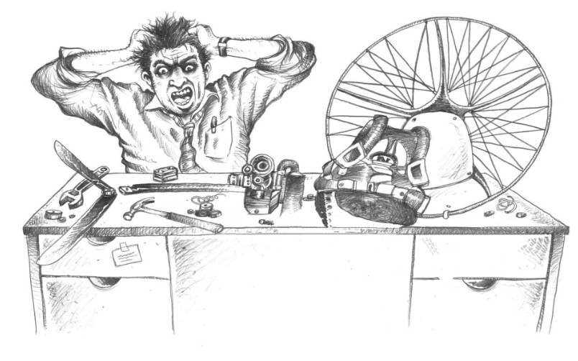

Why two-stroke paramotors and not four-stroke?
Technical note for instructors and pilots · Version 1.0 · 30 October 2026
Paramotor SA (Pty) Ltd t/a Apex Adventures · SACAA DTO 0012

Technical notes · General

Scope. Why almost every foot-launched paramotor uses a two-stroke engine, what a four-stroke does better, and where each one fits (foot-launch PPG, and trikes for PPT/PPC). Engine figures are the makers' published numbers. Many four-stroke claims on the web come from sellers or personal opinion, so each claim in this note carries its source, and the weak ones are marked. The engine manual always wins.

1. The short answer
- A paramotor is worn on the pilot's back, so engine weight and power-to-weight decide the design. A two-stroke gives the most power for its weight (Wikipedia, "Paramotor": favoured for "high thrust-to-weight ratio of engine plus fuel").
- Same engine size, a four-stroke makes about half the power. It fires once every two turns, a two-stroke every turn. The same blog sources say four-strokes weigh 10 to 50 % more for the same power (unsourced opinion, so treat as indicative).
- A two-stroke is simpler and cheaper: fewer parts, no valves, lower price, easy to repair.
- The price is premixed oil, more noise, higher fuel burn and more frequent top-end attention.
- A four-stroke fits best where the engine does not sit on the pilot's back: trikes and buggies. There the extra weight is carried by the wheels.
- The gap is narrowing from the two-stroke side. The Vittorazi Moster 185 EFI (fuel-injected two-stroke) burns 2.5 L/h against 3.8 to 4.2 L/h for the carburetted Plus.

2. How the two cycles differ
 | Two-stroke | Four-stroke
Cycle | Intake, compression, power and exhaust in two piston strokes (one crank turn) | The same four events in four strokes (two crank turns)
Power strokes | One per crank turn | One per two crank turns. At 6,000 rpm: 6,000 against 3,000 a minute
Valves | None. Ports in the cylinder wall | Intake and exhaust valves, camshaft, timing parts
Lubrication | Oil mixed into the fuel (premix) | Separate oil system with sump and filter
Typical paramotor engines | Vittorazi Moster 185 and Atom 80, Hirth F-33, and most others | Few: for example Cobra 4ST190, Rotax 912 (trikes and ultralights)

Power strokes per minute is the root of the weight difference: for the same size and rpm the two-stroke fires twice as often. (Redback Aviation, a four-stroke supplier's article reprinted 2018, original 1995.)

3. What the numbers show
Published figures for engines Apex staff will meet. Engine-only weight. Thrust figures are static, from different tests with different propellers and rpm, so compare them only roughly.
Engine | Type | Power | Weight | Static thrust (maker) | Fuel use (maker)
Atom 80 | 2-stroke, 78 cc | 16 hp at 9,500 rpm | 10.4 kg | 55 kgf (130 cm, 9,650 rpm) | 2.7 L/h at 30 kgf thrust
Moster 185 Plus | 2-stroke, 185 cc, carb | 25 hp at 7,800 rpm | 14.2 kg | 72 kgf at 8,500 rpm | 3.8 to 4.2 L/h
Moster 185 EFI | 2-stroke, injected | 26 hp at 8,600 rpm | 16.9 kg | 92 kgf at 8,600 rpm | 2.5 L/h
Moster 185 Factory R | 2-stroke, racing | 27 hp at 8,800 rpm | 13.7 kg | 93 kgf at 9,000 rpm | 4 L/h
Hirth F-33 | 2-stroke, single cylinder | 22 hp at 5,200 to 28 hp at 6,500 rpm | 14.1 kg dry (45 lb with e-start and reduction) | not given | not given
Cobra 4ST190 | 4-stroke | not given | 19 kg | 67 kgf (130 cm, 2 blades) | not given

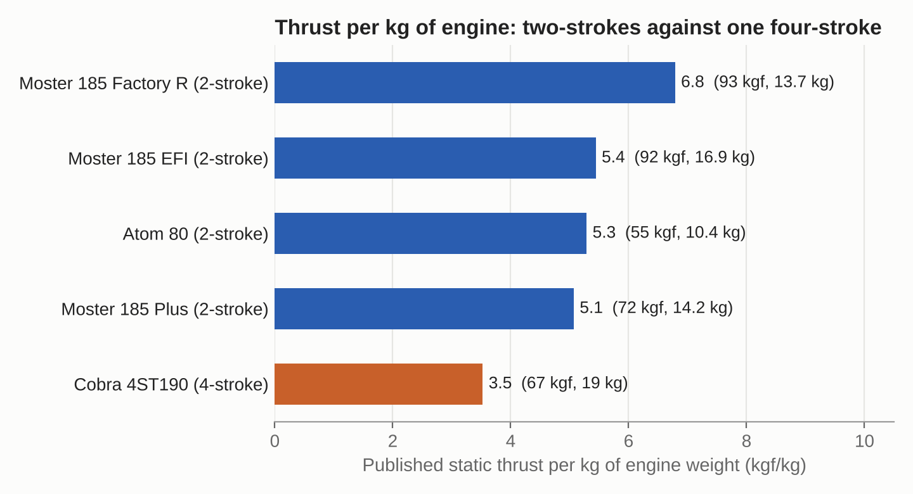
Published static thrust divided by engine weight. Calculated by us from the makers' figures above. Test conditions differ, so the ranking is indicative, not a measurement. Apex chart.
How to read this:
- Power per kg of two-stroke: Moster Plus 1.8 hp/kg, EFI 1.5, Factory R 2.0, Atom 80 1.5, Hirth F-33 2.0 (calculated).
- The only paramotor four-stroke with a published weight and thrust (Cobra) gives 3.5 kgf per kg of engine against 5.1 to 6.8 for the two-strokes. That is one engine, from a 2016 magazine report, so it shows the pattern, not a rule.
- The Moster Plus thrust is 72 kgf on one page and 78 kgf (130 cm prop) on another. Different pages and props give different numbers. Always quote the source and the propeller.
- The injected two-stroke is 2.7 kg heavier than the Plus but 1.5 L/h thriftier (calculated from the maker's page). Fuel injection, not the four-stroke cycle alone, is what saves fuel on a paramotor.

4. Why two-strokes win on the back
- Weight in the pilot's legs and back. Every kilogram is carried on take-off and landing runs. A four-stroke of equal power is heavier, or a four-stroke of equal weight makes less thrust.
- Thrust for take-off. Foot launching needs high thrust at once, with a lightweight frame. Seller and blog sources say most four-strokes do not offer enough thrust for heavier pilots.
- Simplicity and cost. No valve train, so fewer parts to buy, fit, adjust or rebuild. Many owners do their own top-end work.
- Size. A two-stroke is compact, which keeps the cage small and the thrust line close to the pilot.
- Established supply. Maker support, parts, propeller matching and repair knowledge in South Africa are built around two-strokes. That is a practical point from the Apex fleet, not a published figure.

5. What a four-stroke does better
Advantage | Claim and source | Evidence
No premixing | Pilot does not mix oil into fuel (Paramotor Planet) | General fact of the cycle
Lower fuel burn | "Extremely low" use claimed (TrikeBuggy, a seller). About 2 L/h claimed for 30 to 35 hp (blog author, never flew one) | Weak. No test figures given
Smoother, quieter | Smoother power delivery and better low-down power (Paramotor Planet). Lower noise (TrikeBuggy) | Opinion, no decibel figures
Longer life between overhauls | Rotax 912 overhaul interval 1,200 h against 2-stroke top end at 150 to 200 h and full overhaul about 500 h (Redback, reprint of 1995 article) | Not paramotor-specific. Rotax 912 is a heavier 80 hp trike and aircraft engine
Less wear at lower rpm | Lower revving means less maintenance (Paramotor Planet) | General engineering reasoning
Cleaner exhaust | Two-strokes pass some unburned fuel and give more emissions (outdoortroop.com blog) | General fact of the cycle

Where four-strokes make sense: trikes and buggies, where wheels carry the engine and the pilot does not wear it. TrikeBuggy's designer says this plainly: "we can now use a heavier, more reliable power plant since we don't have to carry it on our backs" (seller claim, not an independent test). For Apex, that is the PPT/PPC side of the school.

6. Two-stroke downsides to teach
- Premix must be right. Atom 80 (Vittorazi): unleaded petrol with 2.0 % Motul 710 or 1.5 % Motul 800 synthetic oil, about 50:1 or 67:1. Always use the engine maker's ratio and oil. Never run a two-stroke on neat petrol.
- Lean running can seize a two-stroke quickly. The oil rides in the fuel, so a lean or starved engine loses cooling and lubrication together. See the Walbro WB37C note and the Spark Plug note for mixture and plug checks.
- High revs mean more wear. Frequent top-end inspection is normal practice, and seller articles quote 150 to 200 h for a top end (general, not an Apex figure). Use the maker's interval.
- Noise and smell. Louder and smokier than a four-stroke. Maker tuned exhausts (the Atom 80 has one) cut noise but do not remove it.
- Seller claims of sudden stops (TrikeBuggy says most two-stroke paramotors have reliability issues) are a sales opinion, with no data given. Do not repeat them to students. Prevent engine stops with correct mix, maintenance and fuel discipline, and always fly with a landing option in reach.
Instructor rule of thumb. Match the engine's fuel and oil to its manual, not to what another engine uses. A two-stroke fed the wrong oil ratio, or a four-stroke fed premix, is damaged within minutes. Label every fuel can.

7. Which engine for which job
Use | Better fit | Why
Foot-launch PPG | Two-stroke | Lowest weight, highest thrust for the weight, cheapest to buy and rebuild
Trike or buggy (PPT/PPC) | Two-stroke or four-stroke | Weight is carried by the wheels. Four-stroke offers no premix and long service intervals, at the price of more weight and cost
Heavy pilot, high take-off thrust | Large two-stroke, such as the Moster 185 | Thrust per kg is highest in published figures
Quiet, low-fuel flying where weight is not critical | Four-stroke or fuel-injected two-stroke | Injection (Moster EFI) is the lighter route to lower fuel burn

8. Apex engine record
Fill in from each engine's manual. Rows are to be confirmed against the MY25 manuals.
Engine | Type | Displacement | Rated power | Weight | Oil / mix ratio | Overhaul interval | Source
Vittorazi Atom 80 | 2-stroke | 78.2 cc | 16 hp / 9,500 rpm | 10.4 kg | 2.0 % Motul 710 or 1.5 % Motul 800 |  | Vittorazi page. Confirm in manual
Vittorazi Moster 185 Plus | 2-stroke | 184.7 cc | 25 hp / 7,800 rpm | 14.2 kg |  |  | Parajet page. Confirm in manual

9. Sources and cautions
- Atom 80 (Vittorazi, vittorazi.com). Weight 10.4 kg, 16 hp, thrust, fuel use, mix ratios, manual start, reduction 1/3.8.
- Mav Max paramotor (Parajet, parajet.com). Moster 185 Plus, EFI and Factory R weights, power, thrust and fuel figures.
- Hirth F-33 (Wikipedia). Two-stroke, 22 hp at 5,200 rpm and 28 hp at 6,500 rpm, 14.1 kg dry.
- Cobra 4ST190 4-stroke paramotor (XC Mag, October 2016). Four-stroke, 19 kg, 67 kgf with a 130 cm propeller.
- Paramotor (Wikipedia). Two-strokes dominate for thrust-to-weight of engine plus fuel. Four-stroke claim is flagged there as needing a citation.
- Paramotor 4 stroke vs 2 stroke engines: which is best? (paramotorplanet.com, author "Darrell"). Opinion article. Weight, power and cost claims, no test figures.
- Why are paramotor engines usually 2-strokes? (outdoortroop.com). General blog. Author has not flown a four-stroke. Internally inconsistent on weight.
- Four stroke versus two stroke engines (Redback Aviation, reprint of a 1995 article). Power impulses, Rotax 912 overhaul interval. Dated and not paramotor-specific.
- Four-stroker (trikebuggy.com, seller of the Thumper 4-stroke). Designer's claims on weight, noise and reliability for trikes.
Cautions.
- Seller and blog claims are marked as such. No independent test data comparing paramotor two-strokes and four-strokes was found.
- The Cobra 4ST190 article is from 2016. The engine may be out of production or changed. Only one paramotor four-stroke has weight and thrust figures here, so that comparison is weak.
- The Rotax 912 figures are for aircraft and trikes, not foot-launch paramotors.
- Thrust per kg figures are calculated by us from maker numbers measured under different conditions.
- The PPG Bible, APCO and Dudek, and Xplorer articles were not available for this version. Add them when attached.
- This note is a technical aid. It does not replace the manufacturers' manuals or the DTO's procedures.
Reviewed and approved by CFI: ___________________________ Date: _____________

